Name

Mathematics Advanced Year 12
Rates of Change

Book 1 |  | Version: 261020  Feedback:  https://MrDingMaths.com
Contents
Syllabus Content 2
Learning Intention 3

Syllabus Content
MAV-12-06 applies calculus to graph functions and model and solve problems involving optimisation, rates of change and motion in a line
- Use differentiation to find and interpret the first and second derivatives, $\frac{dQ}{dt}$ and $\frac{d^{2}Q}{dt^{2}}$, in practical problems where a quantity $Q$ is a function of time $t$
- Use integration to solve practical problems on the rate of change of a quantity $Q,$ where $\frac{dQ}{dt}$ or $\frac{d^{2}Q}{dt^{2}}$ is given as a function of time $t$, together with sufficient initial conditions
- Describe and examine the graphs of practical situations where the rate of change of a quantity is proportional to the quantity
- Explain that if the rate of change of a positive quantity $Q$ over time $t$ is proportional to the size of $Q$, then this may be represented by $\frac{dQ}{dt}=kQ$ where $k$ is the constant of proportionality, and if $k>0$ the quantity $Q$ is increasing at a rate proportional to the value of $Q$ at time $t$, while if $k<0$ the quantity $Q$ is decreasing at a rate proportional to the value of $Q$ at time $t$
- Verify by substitution that the function $Q=Ae^{kt}$ satisfies the relationship $\frac{dQ}{dt}=kQ$ with $A$ being the initial value of $Q$
- Recognise that the equation $\frac{dQ}{dt}=kQ$ where $Q>0$, and its solution $Q=Ae^{kt}$ represent exponential growth when $k>0$ and exponential decay when $k<0$
- Graph the function $Q=Ae^{kt}$, where $k>0$ and $k<0$ and $A>0$ and $A<0$, with and without graphing applications, and identify any asymptotes
- Model and solve growth and decay problems in various contexts using $\frac{dQ}{dt}=kQ$, $Q=Ae^{kt}$ and the graph of $Q=Ae^{kt}$ for $t≥0$, and justify conclusions in the context of the problem
- Determine the velocity and acceleration of a particle moving in a straight line given its displacement from a point as a function of time, and use the notation $\frac{d^{2}x}{dt^{2}}$ or $\ddot{x}$ to represent acceleration
- Solve problems relating to the motion of a particle moving in a straight line, using both differentiation and integration to connect the concepts of displacement, velocity and acceleration

Rates of Change of Physical Quantities

- Example Find and interpret $\frac{dQ}{dt}$ and $\frac{d^{2}Q}{dt^{2}}$
The volume $V$ litres of water in a tank $t$ minutes after a pump is switched on is

$$V = 500 + 36t^{2}- t^{3}, t∈[0,24]$$

- Find the rate at which the volume is changing when $t=20$.
- Find $\frac{d^{2}V}{dt^{2}}$ when $t = 20$.
- Describe what is happening to the volume of water when $t=20$.
a)  $$\frac{dV}{dt}=72t-3t^{2} \\ {\frac{dV}{dt}}_{t=20}=72\left(20\right)=3{\left(20\right)}^{2} \\ =240$$ | b)  $$\frac{dV^{2}}{dt^{2}}=72-6t \\ {\frac{dV^{2}}{dt^{2}}}_{t=20}=72-6\left(20\right) \\ =-48$$
At $t=20,$ the volume is increasing at 240 L/min.
The rate of increase is slowing down at $48$ L/m²

- Guided Practice
- The volume $V$ litres of water in a tank $t$ minutes after a pump is switched on is
$$V = 500 + 36t^{2}- t^{3}, t∈\left[0,24\right]$$
Find $\frac{dV}{dt}$ and $\frac{d^{2}V}{dt^{2}}$ at $t=10$ and describe what is happening to the volume when $t=10$.

Volume increasing at 420 L/min
And the rate of increase is speeding up at 12 L/min²
- Water drains from a pond so that
$$V = 2000-40t-t^{2}, t∈\left[0,25\right]$$
Find $\frac{dV}{dt}$ and $\frac{d^{2}V}{dt^{2}}$ at $t=15$ and describe what is happening to the volume when $t=15$.

Volume increasing at 70 L/min
And the rate of decrease is speeding up at 2 L/min²
- Greatest Rate
When asked to find the ‘fastest rate’ of increase or decrease of a quantity $Q$, find the turning points of $\frac{dQ}{dt}.$
1. Find $\frac{d^{2}Q}{dt}$.
2. Solve for $\frac{d^{2}Q}{dt}=0$.
3. Show this is a maximum or minimum.
4. State answer with time and units.

- Example Find the greatest rate of change
The number of people $P$ in a shopping centre $t$ hours after 9 am is

$$P = 150 + 54t^{2}-4t^{3}, t∈[0,9]$$

Find the time when people are entering the centre at the greatest rate and find this rate.
1.  $$\frac{dP}{dt}=108t-12t^{2}$$  $$\frac{d^{2}P}{dt^{2}}=108-24t$$  2.  $$108-24t=0 \\ 24t=108 \\ t=4.5$$ | 3.  Since $\frac{d^{2}P}{dt^{2}}$ changes from positive to negative, $\frac{dP}{dt}$ max at $t=4.5$  4.  $${\frac{dP}{dt}}_{t=4.5}=108\left(4.5\right)-12{\left(4.5\right)}^{2}=243$$  The greatest rate is 243 people per hour, at 1:30 pm.
  $$t$$ | 4 | 4.5 | 5
  $$\frac{d^{2}P}{dt^{2}}$$ | 12 | 0 | $$-12$$

- Guided Practice
- People entering a shopping centre after 9 am is given by
$$P=150+54t^{2}-3t^{3}$$
Find the time of the greatest rate of entry and the rate at this time.

324 people per hour at 3 pm
- Water flows into a tank at $\frac{dV}{dt}=40t-4t^{2}$ L/min. Find the greatest rate of flow.

100 L/min
- A tank drains so that $V=3600{\left(1-\frac{t}{60}\right)}^{2}$.
Show that $\frac{dV}{dt}$ has no stationary points and therefore find when the water drains fastest.

$\frac{d^{2}V}{dt^{2}}=2$, so no stationary point for $\frac{dV}{dt}$. Check the endpoints. Water drains fastest at $t=0$ at 120 L/min
- Change in Quantity
The change in the quantity between $t=a$ and $t=b$ is:
$$\int_{a}^{b}{\frac{dQ}{dt}dt=}Q\left(b\right)-Q\left(a\right)$$

- Example Find the change between two times
Water flows into a tank at a rate of

$$\frac{dV}{dt}=9t^{2}+20 L/min$$

How much water flows into the tank between $t=2$ and $t=5$?

$$V=\int_{2}^{5}{\left(9t^{2}+20\right)}dt \\ ={\left[3t^{3}+20t\right]}_{2}^{5} \\ =\left(3{\left(5\right)}^{3}+20\left(5\right)\right)-\left(3{\left(2\right)}^{3}+20\left(2\right)\right) \\ =411 L$$

- Guided Practice
- Rainwater flows into a tank at a rate of $\frac{dQ}{dt}=3\sqrt{t}+5$ L/h.
How much water flows into the tank between $t=1$ and $t=9$?

92 L
- Oil leaks from a tanker at $\frac{dV}{dt}=200e^{-0.4t}$ L/h. How much oil leaks in the first 5 hours?

432 L

Exponential Growth and Decay

- Review
- Solve exponential equations, leaving answers in exact form.
- $1.9=e^{5k}$ | - $17=5e^{2k}$ | - $14e^{7k}=9$

- Solve direct and inverse variation problems
- The petrol used by a car at a constant speed is directly proportional to distance travelled.
A car uses 6 L of petrol to travel 50 km.
How much petrol is needed to travel 180 km?

- The number of students wearing jumpers is inversely proportional to temperature. When it is 15°C, there are 1000 students wearing jumpers.
How many students wear jumpers when it is 20°C?

- Identify what the question is asking for
The population of a town is given by $P\left(t\right),$ where $t$ is in days.
For each question, identify what the question is asking for:
- Find the population after 1000 days | - Find when the population is 1000.
- Find the rate of change after 1000 days. | - Find when the rate of change is 1000/day
- Find the population when the rate of change is 1000/day. | - Find the rate of change when the population is 1000.

- Exponential Growth and Decay
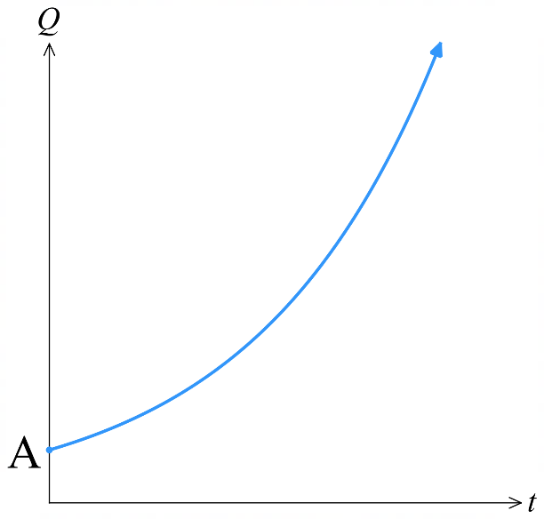
For exponential change, the rate of change is directly proportional to the current amount.
More quantity means faster change.
Population growth:
- Small population:
Few individuals reproducing = slow growth.
- Large population:
Many individuals reproducing = rapid growth.
Radioactive decay:
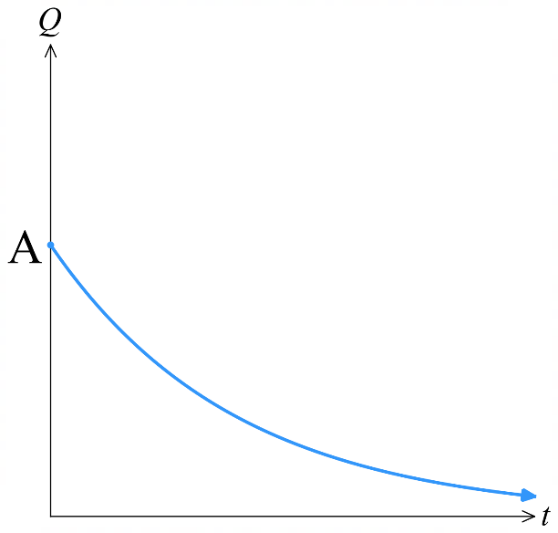
- Large mass:
Many atoms decaying = high decay rate.
- Small mass:
Fewer atoms decaying = slower decay rate.
growth constant
$k$ positive for growth
$k$ negative for decay

initial quantity
$$t=0$$
$$If Q=Ae^{kt}, \frac{dQ}{dt}=kAe^{kt} \\ =kQ$$

- Interpret Exponential growth and decay.
A population is changing according to  $$P\left(t\right)=100e^{2t}$$  - Show $\frac{dP}{dt}$ $=kP$  - Sketch the graph of $y=P\left(t\right)$.  - What is the initial population?  - What happens as $t→∞$? | The mass of a substance is changing according to  $$M\left(t\right)=100e^{-2t}$$  - Show $\frac{dM}{dt}$ $=kM$  - Sketch the graph of $y=M\left(t\right)$.  - What is the initial mass?  - What happens as $t→∞$?

- Finding the value of $k$.
Exponential growth and decay problems usually involve finding the value of $k$.
$$if \frac{dQ}{dt}=kQ, then Q=Ae^{kt}$$
            - Write $Q=Ae^{kt}$. Remember that $A$ is the initial quantity.
            - Substitute in given values and solve for $k$. Leave in exact form.
            - Rewrite equation with $A$ and $k$.
            - Solve for what the question asks for.
- In questions where you need to find the derivative or solve for $t$,
write $k$ instead of its exact value to avoid writing a complex logarithm every line.

- Example Solve exponential growth and decay problems.
A vessel of water is being emptied.
The rate of change of the water is proportional to the amount of water.
Initially, it has 100 m³ of water.
After 5 minutes, it has 90 m³.
Find how much water remains after 20 minutes.

1. $Q=Ae^{kt}$  $$Q=100e^{kt}$$  2. $90=100e^{k\left(5\right)}$  $$0.9=e^{5k}$$  $$\ln{0.9}=5k$$  $$k=\frac{\ln{0.9}}{5}$$  3. $Q=100e^{\left(\frac{\ln{0.9}}{5}\right)t}$  4. $Q\left(20\right)=100e^{\left(\frac{\ln{0.9}}{5}\right)\left(20\right)}$  $=65.61$ m³ | How do we know the equation is in the form $Q=Ae^{kt}$?  The question says: ……………………………  How did we know the value of $A?$  $A$ is the ……………… amount.  We can prove this by substituting $\left(0,100\right):$  $$Q=Ae^{kt}$$  How did we know to substitute $\left(5,90\right)$ into the equation to find $k$?  The question says 5 ……………, so … = 5  The question says 90 ……, so … = 90  This question asked us for $Q\left(20\right)$, what would the question ask if it wanted:  $Q'(20)$? ………………………………………….  $Q\left(t\right)=20$? ………………………………………  $Q'\left(t\right)=20$? ……………………………………...

- Practice
The mass M of a radioactive substance is initially 10 grams.
The rate of decay of a radioactive substance is proportional to the
mass of the substance present.
Twenty years later the mass of remaining radioactive substance is 9.6 grams.
In how many years will the mass of radioactive substance be half the original?

347 years
The rate of growth of bacteria in a culture is proportional to the amount present.
A starting culture of 6000 bacteria increases to 9000 after 8 hours.
- Find the number of bacteria after 2 days.
- Find the rate at which bacteria are increasing after 2 days.
- Find when the number of bacteria will reach 1 000 000.

68344 bacteria
3434 bacteria/hr
100.9 hours

Foundation
- Ten years ago, the population of a certain town was 25000 and today, it is 30000.
Let the rate of the population be given by $\frac{dP}{dt}$ $= kP$,
where $k$ is a constant and $t$ is the time since ten years ago.
  - Show that $P = P_{0}e^{kt}$ satisfies this equation.
$$P = P_{0}e^{kt}$$
$$\frac{dP}{dt}= kP_{0}e^{kt}= kP$$
  - Find the exact value of $k$.
$$At t = 0: 25000 = P_{0}e^{0}$$
$$∴P_{0}=25000$$
$$At t = 10: 30000 = 25000e^{10k}$$
$$e^{10k}=\frac{30000}{25000}=\frac{6}{5}$$
$$10k = ln\left(\frac{6}{5}\right)$$
$$k = \left(\frac{1}{10}\right)ln\left(\frac{6}{5}\right)$$
  - Hence, find the rate at which the population was growing ten years ago, and the rate that it is growing today to the nearest person per year.
$$\frac{dP}{dt}= kP$$
$$Ten years ago \left(t = 0\right): \frac{dP}{dt}= k\left(25000\right)= \left(\frac{1}{10}\right)ln\left(\frac{6}{5}\right)\left(25000\right)= 2500ln\left(\frac{6}{5}\right)≈ 456 people per year$$
$$Today \left(t = 10\right): \frac{dP}{dt}= k\left(30000\right)= \left(\frac{1}{10}\right)ln\left(\frac{6}{5}\right)\left(30000\right)= 3000ln\left(\frac{6}{5}\right)≈ 547 people per year$$
- The output in a factory increases according to the equation $P = P_{0}e^{kt}$ where $t$ is years.
  - Find P₀ if the initial output is 5000 units.
At t = 0: P = 5000
P₀ = 5000
  - The factory produces 8000 units after 3 years. Find the value of $k$, to 3 decimal places.
$$At t = 3: P = 8000$$
$$8000 = 5000e^{3k}$$
$$e^{3k}=\frac{8}{5}$$
$$3k = ln\left(\frac{8}{5}\right)$$
$$k = \left(\frac{1}{3}\right)ln\left(\frac{8}{5}\right)= 0.157$$
  - How many units will the factory produce after 6 years?
$$At t = 6:$$
$$P = 5000e^{6k}= 12800 units$$
  - The factory needs to produce 20000 units to make a maximum profit.
After how many years, correct to 1 decimal place, will this happen?
$$20000 = 5000e^{kt}$$
$$e^{kt}= 4$$
$$kt = ln\left(4\right)$$
$$t =\frac{ln\left(4\right)}{k}=\frac{ln\left(4\right)}{0.157}= 8.8 years$$
- The population $P$ of a rural town has been declining over the last few years.
Five years ago, the population was estimated at 30000 and today it is estimated at 21000.
  - The population obeys the exponential decay model $\frac{dP}{dt}$ $= -kP$, for some positive constant $k$, where $t$ is time in years from the first estimate, and show that $P = 30000e^{-kt}$ satisfies this differential equation and the initial condition.
$$P = 30000e^{-kt}$$
$$\frac{dP}{dt}= 30000\left(-k\right)e^{-kt}= -k\left(30000e^{-kt}\right)= -kP$$
  - Find the exact value of the positive constant $k$.
$$21000 = 30000e^{-5k}$$
$$e^{-5k}=\frac{21000}{30000}=\frac{7}{10}$$
$$-5k = ln\left(\frac{7}{10}\right)$$
$$k = -\frac{1}{5}ln\left(\frac{7}{10}\right)=\frac{1}{5}ln\left(\frac{10}{7}\right)$$
  - Estimate the population ten years from now.
$$At t = 15 (ten years from now):$$
$$P = 30000e^{-15k} = 30000e^{-15\left(\frac{1}{5}\right)ln\left(\frac{10}{7}\right)}=10290$$
  - The local bank has estimated that it will not be profitable to stay open once the population falls below 16000. When will the bank close?
$$16000 = 30000e^{-kt}$$
$$e^{-kt}=\frac{8}{15}$$
$$-kt = ln\left(\frac{8}{15}\right)$$
$t = -\frac{ln\left(\frac{8}{15}\right)}{k}≈ 8.8$, sometime in the fourth year from now.
- The amount $C$ of a carbon isotope in a dead tree trunk is given by $C = C_{0}e^{-kt}$, where $t$ is measured in years from the death of the tree, and $k$ is a positive constant.
  - Explain the significance of C₀.
C₀ is the amount of the carbon isotope from when the tree was alive.
  - Find $k$, correct to four significant figures, if the half-life of the isotope is 6000 years.
$$At half life, C =\frac{C_{0}}{2}when t = 6000$$
$$\frac{C_{0}}{2}= C_{0}e^{-6000k}$$
$$\frac{1}{2}= e^{-6000k}$$
$$-6000k = ln\left(\frac{1}{2}\right)= -ln\left(2\right)$$
$$k =\frac{ln\left(2\right)}{6000}= 1.155 × {10}^{-4}$$
  - A dead tree trunk has 12% of the amount of the isotope compared to what a typical living tree would have. How many years ago did the tree die, correct to the nearest 1000 years?
$$0.12C₀ = C_{0}e^{-kt}$$
$$0.12 = e^{-kt}$$
$$-kt = ln\left(0.12\right)$$
$$t = -\frac{ln\left(0.12\right)}{k}= -\frac{ln\left(0.12\right)}{1.155 × {10}^{-4}}= 18000 years ago$$

Development
- The population of a country is increasing at a yearly rate of 6.9%; that is, $\frac{dP}{dt}$ $= 0.069P$.
If the population was 50000 at the start of 2015, find:
  - a formula for the population growth in terms of $e$ and $t$.
$$P=Ae^{kt}$$
$$P^{'}=kAe^{kt}=kP=0.069P$$
So, $k=0.069$ and $A=50000$
$$P = 50000e^{0.069t}$$
  - the population in the year 2020
$$At t = 5 \left(year 2020\right):$$
$$P = 50000e^{0.069×5}= 70599$$
  - the rate at which the population will be growing in the year 2020
$$\frac{dP}{dt}= 0.069P = 0.069 × 70599 = 4871 people per year$$
  - in which year the population will reach 300000.
$$300000 = 50000e^{0.069t}$$
$$e^{0.069t}= 6$$
$$0.069t = ln\left(6\right)$$
$$t =\frac{ln\left(6\right)}{0.069}= 25.9$$
$$Year = 2015 + 25.9 = 2040.9 \left(towards end of 2040\right)$$
- The mass $M$ of a chemical in a system undergoing a reaction is given by the equation
$M = M_{0}e^{-kt}$. It is known that 200 kg of the chemical reduced to 160 kg after three hours.
  - Show that there is exactly 128 kilograms of the chemical remaining after six hours.
$$At t = 0: M_{0} = 200$$
$$At t = 3: M = 160$$
$$160 = 200e^{-3k}$$
$$e^{-3k}=\frac{4}{5}$$
$$-3k = ln\left(\frac{4}{5}\right)$$
$$k = -\frac{ln\left(\frac{4}{5}\right)}{3}=\frac{ln\left(\frac{5}{4}\right)}{3}$$
$$At t = 6:$$
$$M = 200e^{-6k}= 128 kg$$
  - Find the rate at which the mass is reducing after six hours, correct to two decimal places.
$$\frac{dM}{dt}= -kM = -k\left(128\right)= -\left(\frac{ln\left(\frac{5}{4}\right)}{3}\right)\left(128\right)= -9.52 kg per h$$
  - Find how long it will take for 80% of the chemical to react, correct to two decimal places.
$$When 80\% reacts, 20\% remains: M = 0.2 × 200 = 40$$
$$40 = 200e^{-kt}$$
$$e^{-kt}=\frac{1}{5}$$
$$-kt = ln\left(\frac{1}{5}\right)= -ln\left(5\right)$$
$$t =\frac{ln\left(5\right)}{k}=21.64 hours$$
- 2019 HSC Advanced Band 4
The number of leaves, $L(t)$, on a tree $t$ days after the start of autumn can be modelled by
$$L(t) = 200000e^{-0.14t}$$
  - What is the number of leaves on the tree when $t$ = 31?
  - What is the rate of change of the number of leaves on the tree when $t$ = 31?
  - For what value of $t$ are there 100 leaves on the tree?
a) When t = 31
$L(31) =$ $200000e^{-0.14\left(31\right)}$ = 2607 leaves
b) $L(t) = 200000e^{-0.14t}$
$$\frac{dL}{dt}= -0.14 × 200000e^{-0.14t}= -28000e^{-0.14t}$$
When $t = 31$:
$$\frac{dL}{dt}= -28000e^{-0.14\left(31\right)}= -28000e^{-4.34}= -365 leaves per day$$
c) Find $t$ when $L$ = 100:
$$100 = 200000e^{-0.14t}$$
$$e^{-0.14t}=\frac{100}{200000}= 0.0005$$
$$-0.14t = ln\left(0.0005\right)$$
$$t = -\frac{ln\left(0.0005\right)}{0.14}=\frac{ln\left(2000\right)}{0.14}= 54.3 days$$
- 2009 HSC Advanced Band 5
Radium decays at a rate proportional to the amount of radium present. That is, if $Q(t)$ is the amount of radium present at time $t$, then $Q = Ae^{-kt}$, where $k$ is a positive constant and $A$ is the amount present at $t = 0$. It takes 1600 years for an amount of radium to reduce by half.
  - Find the value of $k$ to 4 s.f.
  - A factory site is contaminated with radium. The amount of radium on site is currently three times the safe level. How many years will it be before the amount of radium reaches the safe level?
$$a) Q = Ae^{-kt}$$
$$When t = 0: Q = A$$
$$When t = 1600: Q = \left(\frac{1}{2}\right)A$$
$$\left(\frac{1}{2}\right)A = Ae^{-1600k}$$
$$\frac{1}{2}= e^{-1600k}$$
$ln\left(\frac{1}{2}\right)= -1600k$r
$$-1600k = ln\left(\frac{1}{2}\right)$$
$$k = -\frac{ln\left(\frac{1}{2}\right)}{1600}= 0.0004332 \left(to 4 sig. figures\right)$$
$$b) Find t when Q = \left(\frac{1}{3}\right)A:$$
$$\left(\frac{1}{3}\right)A = Ae^{-kt}$$
$$\frac{1}{3}= e^{-kt}$$
$$ln\left(\frac{1}{3}\right)= -kt$$
$$t = -\frac{ln\left(\frac{1}{3}\right)}{k}= 2536 years$$

Mastery
- 2013 HSC Advanced Band 6
Trout and carp are types of fish. A lake contains a number of trout. At a certain time, 10 carp are introduced into the lake and start eating the trout. As a consequence, the number of trout, N, decreases according to
$$N = 375 - e^{0.04t}$$
where $t$ is the time in months after the carp are introduced.
The population of carp, P, increases according to $\frac{dP}{dt}= 0.02P$.
  - How many trout were in the lake when the carp were introduced?
  - When will the population of trout be zero?
  - Sketch the number of trout as a function of time.
  - When is the rate of increase of carp equal to the rate of decrease of trout?
  - When is the number of carp equal to the number of trout?
a) $At t = 0:$  $$N = 375 - e^{0}= 374 trout$$  b) When $N = 0$:  $$0 = 375 - e^{0.04t}$$  $$e^{0.04t}= 375$$  $$0.04t =\ln{375}$$  $$t =\frac{ln375}{0.04}= 148 months$$  c)  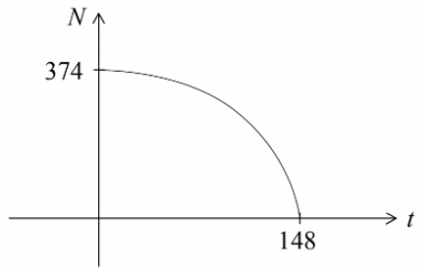 | d) Need $\left|\frac{dN}{dt}\right|=\frac{dP}{dt}$  Given $N = 375 - e^{0.04t}$  $$\frac{dN}{dt}= -0.04e^{0.04t}$$  Given $\frac{dP}{dt}$ $= 0.02P$  From $P = Ae^{0.02t}$, when $t = 0, P = 10$  ∴ $A = 10$  $$P = 10e^{0.02t}$$  $$\frac{dP}{dt}= 10 × 0.02e^{0.02t}= 0.2e^{0.02t}$$  Setting $\left|\frac{dN}{dt}\right|=\frac{dP}{dt}:$  $$0.04e^{0.04t}= 0.2e^{0.02t}$$  $$\frac{e^{0.04t}}{e^{0.02t}}=\frac{0.2}{0.04}= 5$$  $$e^{0.04t-0.02t}= 5$$  $$e^{0.02t}= 5$$  $$0.02t = ln5$$  $$t =\frac{ln5}{0.02}= 80 months$$  e) When $N = P$:  $$375 - e^{0.04t}= 10e^{0.02t}$$  $$Let X = e^{0.02t}, then X^{2}= e^{0.04t}$$  $$375 - X² = 10X$$  $$X² + 10X - 375 = 0$$  $$\left(X + 25\right)\left(X - 15\right)= 0$$  $$X = 15 \left(since X > 0\right)$$  $$e^{0.02t}= 15$$  $$0.02t = ln15$$  $$t =\frac{ln15}{0.02}= 135 months$$

Motion and Integration

- Displacement, Velocity, Acceleration
We can find displacement by integrating velocity, and velocity by integrating acceleration.
Displacement  $$x=\int{v}dt$$ | Velocity  $$v=\int{a}dt$$

- Example Find displacement by integration given velocity equation
The velocity of a particle moving in a straight line is given by $v=12t^{2}-6t+5$m/s.
Initially, the particle is 2 m to the left of the origin, find its displacement after 2 seconds.
1. Indefinite integral  $$x=\int{(12t^{2}-6t+5)}dt$$  $$=4t^{3}-3t^{2}+5t+C$$  2. Find C  At $t=0, x=-2$  $$-2=4{\left(0\right)}^{3}-3{\left(0\right)}^{2}+5\left(0\right)+C$$  $$-2=C$$  $$∴x=4t^{3}-3t^{2}+5t-2$$ | 3. Answer question  $$x\left(2\right)=4{\left(2\right)}^{3}-3{\left(2\right)}^{3}+5\left(2\right)-2$$  $$=28$$  The particle is 28 m to the right of the origin after 2 seconds.

- Guided Practice
- The velocity of a particle is $v = 6t² + 10t - 3$cm/s.
Initially the particle is 4 cm to the left of the origin. Find its displacement after 3 seconds.

86 cm
- The velocity of a particle is $v = 3t² - 8t + 5$m/s$.$
When $t = 1$, the particle is 9 m to the right of the origin.
Find its displacement after 3 seconds.

13 m
- Example Find displacement and velocity by integration given acceleration
The acceleration of a particle is given by $a=8-\frac{3}{{\left(t+1\right)}^{2}}$ m/s².
If the particle is initially moving with velocity 5 m/s and is 1 m to the left of the origin, find its displacement equation.
1. Find velocity equation  $$v=\int{\left(8-3{\left(t+1\right)}^{-2}\right)dt} \\ =8t+3{\left(t+1\right)}^{-1}+C_{1}$$  At $t=0,v=5$  $$5=8\left(0\right)+3{\left(0+1\right)}^{-1}+C_{1}$$  $$5=3+C_{1}$$  $$C_{1}=2$$  $$v=8t+3{\left(t+1\right)}^{-1}+2$$ | 2. Find displacement equation  $$x=\int{\left(8t+3{\left(t+1\right)}^{-1}+2\right)dt} \\ =4t^{2}+3\ln\left|t+1\right|+2t+C_{2}$$  At $t=0,x=-1$  $$-1=4{\left(0\right)}^{2}+3\ln\left|1\right|+2\left(0\right)+C_{2}$$  $$-1=C_{2}$$  $$x=4t^{2}+3\ln\left|t+1\right|+2t-1$$

- Guided Practice
The acceleration of a particle is $a = 6t -\frac{4}{{\left(t + 1\right)}^{2}}$ m/s².
Initially the particle is moving with velocity 9 m/s and is 2 m to the right of the origin.
Find its displacement equation and its exact displacement after 2 seconds.

$20+4\ln{3 }$m

- Displacement, Distance, and the Definite Integral
We can find the distance travelled by a particle between $t=a$ and $t=b$ by finding the area bounded by the graph and the axis.
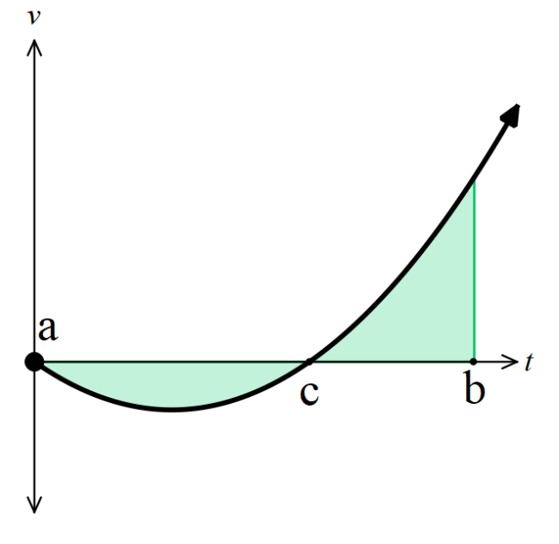
$$d=-\int_{a}^{c}{v}dt+\int_{c}^{b}{v}dt$$

- Example Calculate distance travelled from a velocity equation
The velocity of a particle is $v=3t^{2}-12t$ m/s.
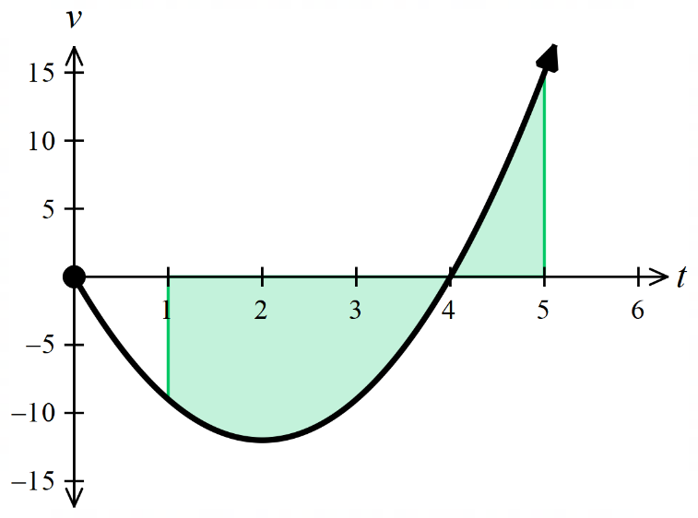
Find the distance travelled by the particle between $t=1$ and $t=5$.
$$d=-\int_{1}^{4}{\left(3t^{2}-12t\right)}dt+\int_{4}^{5}{\left(3t^{2}-12t\right)dt}$$
$$=-{\left[t^{3}-6t^{2}\right]}_{1}^{4}+{\left[t^{3}-6t^{2}\right]}_{4}^{5}$$
$$= -\left(-32 - \left(-5\right)\right)+ \left(-25 - \left(-32\right)\right)$$
$=34$ m

- Guided Practice
- The velocity of a particle is $v=12-3t^{2}$ m/s.
Find the distance travelled by the particle between $t=1$ and $t=5$.

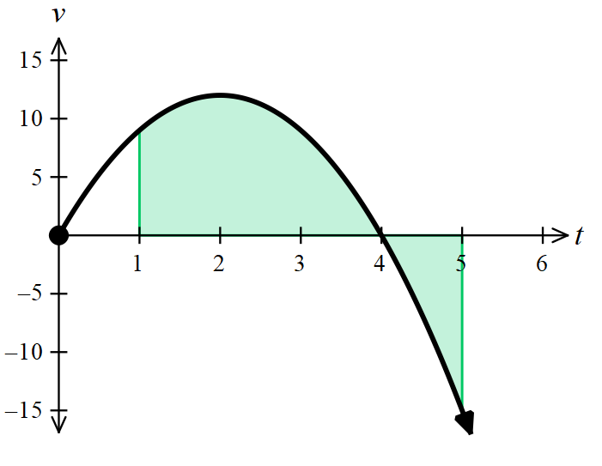

34 m
- The velocity of a particle is $v = 3t^{2}- 6t – 9$ m/s.
Find the distance travelled by the particle between $t=1$ and $t=4$.

23 m
- The velocity of a particle is $v =\sqrt{{\left(t-2\right)}^{2}}$ m/s.
Show that the displacement of the particle between 0 and 4 seconds is 0 metres, but its distance travelled is 4 metres.

